CombGrain User Guide
Dual-engine comb delay, granular texture processor, resonant modulation matrix, and character Space section
Guide for the current development build
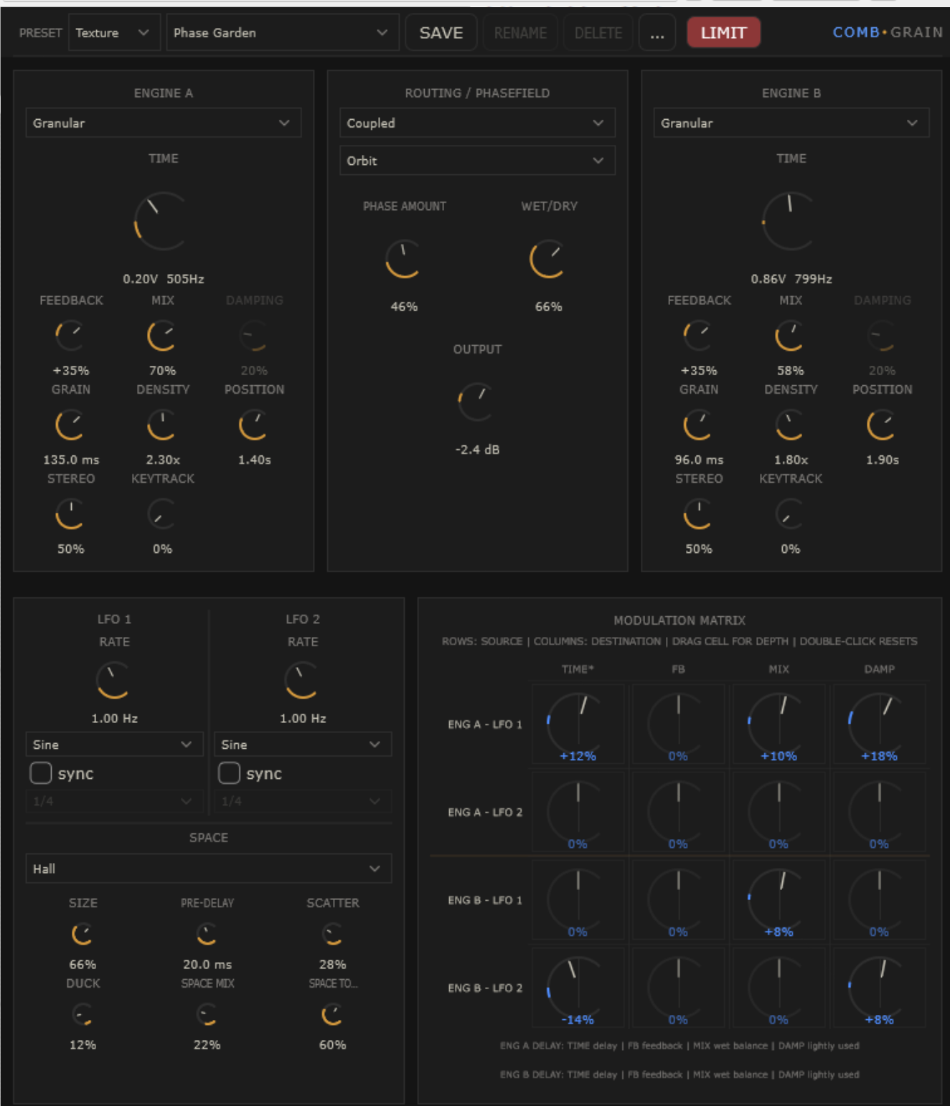
Current interface overview

1. What makes CombGrain unique
CombGrain combines two identical engines that can each run as Delay, Comb, or Granular. Those engines can then be connected through several routing modes and pushed into more active behaviour by the Phasefield system.
Delay gives memory, Comb gives pitch and resonance, Granular gives texture, Phasefield gives motion, and Space gives environment. The plug-in becomes most interesting when those layers are used together rather than in isolation.
- Dual-engine architecture: Engine A and Engine B can each run Delay, Comb, or Granular independently.
- Routing as sound design: Coupled, Decoupled, Series, Ping-Pong, and Send/Return reshape how the engines interact.
- Phasefield modes: Attract, Orbit, and Shatter can pull the engines together, circulate them, or fragment them.
- Mode-aware modulation matrix: the same LFO route means something different depending on the engine mode.
- Space section: Room, Hall, Cathedral, and Spring add character without turning CombGrain into a generic reverb page.
- True wet operation: 100% Wet can be fully wet with no dry signal layered on top.
- Preset workflow: category filtering, Save, Rename, Delete, and Random encourage exploration.

2. Signal flow
Input passes into Engine A and Engine B. Depending on routing, they may run independently, feed each other in series, exchange channel energy, or behave more like a send/return system.
After the engine stage, the signal passes through global Wet/Dry and Output. Space can then add environment and bloom, and LIMIT can catch hotter settings.
- Input -> Engine A / Engine B
- Routing relationship between engines
- Phasefield interaction
- Per-engine internal mix/tone behaviour
- Global Wet/Dry and Output
- Optional Space
- Optional LIMIT

3. Engine section
Each engine uses the same panel. Some controls matter more in certain modes than others, but the layout stays stable so you can switch modes quickly.
Control | Function
Mode | Selects Delay, Comb, or Granular.
Time | Delay time in Delay mode, resonant period/frequency in Comb mode, and pitch-volts / grain-time identity in Granular mode.
Feedback | Recirculation amount. Negative values can hollow, invert, or destabilise the tone.
Mix | Internal wet balance for that engine before the global Wet/Dry stage.
Damping | Tone damping. Most obvious in Delay and Comb modes.
Grain | Grain size in Granular mode.
Density | How often grains are generated in Granular mode.
Position | How widely grains are pulled from different positions.
Stereo | Stereo spread for the engine.
Keytrack | Pitch-following behaviour, useful for tuned combs or pitch-reactive granular sounds.
Delay is best for echoes and memory, Comb for pitched resonance and metallic tone shaping, and Granular for clouds, dust, stutters, and smear.

4. Routing and Phasefield
Routing sets the structural relationship between the engines. Phasefield adds a higher-level behaviour that can make the engines cohere, orbit, or break apart.

Routing modes
- Coupled: direct interaction between the engines.
- Decoupled: more independent behaviour.
- Series: one engine feeds the other.
- Ping-Pong: emphasises cross-channel motion.
- Send/Return: one engine can act like a texture layer around the other.

Phasefield modes
- Off: no extra cross-behaviour.
- Attract: more cohesive, pulled-together motion.
- Orbit: circulating movement and animated relation.
- Shatter: fragmented timing and unstable shards.
Phase Amount controls how strongly the selected Phasefield mode acts. Small values often add life without chaos. High values can become dramatic very quickly.

5. LFOs and modulation matrix
The modulation matrix is fixed-routing and fast to read. Rows are sources, columns are destinations, and each blue matrix cell sets the depth and polarity for that route.

Mode-aware destination mapping
Engine mode | TIME | FB | MIX | DAMP
Delay | Delay time | Feedback | Wet balance | Tone / damping
Comb | Resonant period | Feedback | Wet balance | Tone / damping
Granular | Pitch / time identity | Grain size | Density | Position spread

6. Space section
Space is a compact character section rather than a generic full reverb page. It is meant to place CombGrain’s resonances, delays, and grains into a useful environment while staying tightly integrated with the rest of the plug-in.
Space control | Purpose
Size | Scales the virtual space.
Pre-delay | Delays the Space send before the reverb body starts.
Scatter | Moves the tail from cleaner into smearier, more decorrelated space.
Duck | Reduces the Space return while the source is active, then lets the tail bloom.
Space Mix | Amount of Space in the output.
Space Tone | Brightness / darkness balance for the Space return.
A simple trick: if a preset feels flat, add a little Pre-delay and Scatter first. If the result gets crowded, increase Duck rather than turning everything else down.

7. Wet/Dry, Output, LIMIT, and presets
The global Wet/Dry control is the final balance between source and processed signal. In the current build, 100% Wet is a true wet-only output.

Preset workflow
- Use the category selector to narrow the preset list.
- Save stores a user preset in CombGrain's internal project state.
- Rename and Delete manage user presets.
- Random loads another preset from the current filtered list.

8. Quick-start recipes

Metal comb shimmer
- Set both engines to Comb.
- Use Series routing.
- Add a little Hall or Cathedral Space.
- Use a slow LFO on TIME for gentle pitch movement.

Granular halo cloud
- Set one or both engines to Granular.
- Use Orbit with a medium Phase Amount.
- Increase Position, Density, and Stereo.
- Add Hall with moderate Scatter and some Duck.

Broken spring texture
- Use Granular into Comb or Delay into Spring.
- Raise Tone and a little Scatter.
- Try negative feedback for hollower response.
- Engage LIMIT before exploring louder settings.

Resonant room pulse
- Use Comb plus Delay.
- Try Coupled or Ping-Pong.
- Use Room with a little Pre-delay.
- Assign an LFO to MIX or DAMP for slow breathing motion.

9. Tips and troubleshooting
- If a sound is too noisy or brittle, reduce Feedback, Density, or Scatter first.
- If a sound is too subtle, increase per-engine Mix, then global Wet/Dry, then Phase Amount.
- If you want only the effect return, set Wet/Dry to 100%.
- Use mouse wheel for fine matrix moves and double-click to reset controls.
- Negative Feedback often changes character more dramatically than adding more positive feedback.
- Duck is often the easiest way to keep large spaces playable.

10. Summary
CombGrain works best as a hybrid environment rather than a single-purpose effect. Delay, Comb, Granular, routing, Phasefield, modulation, Space, and LIMIT are designed to push into one another. Start from a preset, make a few deliberate changes, and save your own variations.
CombGrain rewards small moves. A little Phasefield, a little modulation, and a little Space often sound more dimensional than maxing every control.

